REG NO: 230701066  
NAME : K Deepak

DEPT : CSE - A

**SAMPLE PRACTICE PROGRAM**

**QUESTION 1.A**

**AIM :**

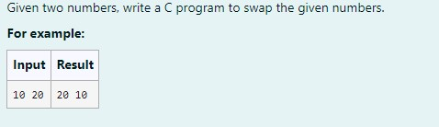

**ALGORITHM :**

Step 1: Start

Step 2: Input integers x and y

Step 3: Store the value of x in temp

Step 4: Assign the value of y to x

Step 5: Assign the value of temp to y

Step 6: Print x and y

Step 7: Stop

**PROGRAM :**

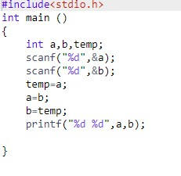

**OUTPUT:**

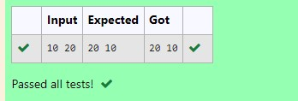

**RESULT :**

The above program is executed successfully.

**QUESTION 1.B**

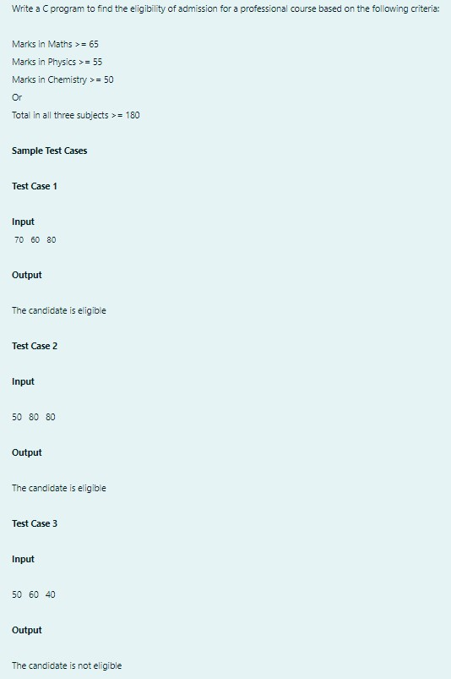

**ALGORITHM:**

Step 1: Start

Step 2: Input marks for Physics (p), Chemistry (c), and Math (m)

Step 3: Check if m >= 65, p >= 55, c >= 50 or if the total marks m + p + c >= 180

Step 4: If true, print "The candidate is eligible"; else, print "The candidate is not eligible" Step 5: Stop

**PROGRAM:**

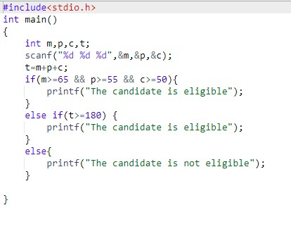

**OUTPUT:**

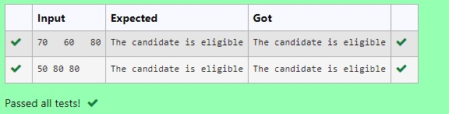

**RESULT:**

The above program is executed successfully.

**QUESTION 1.C**

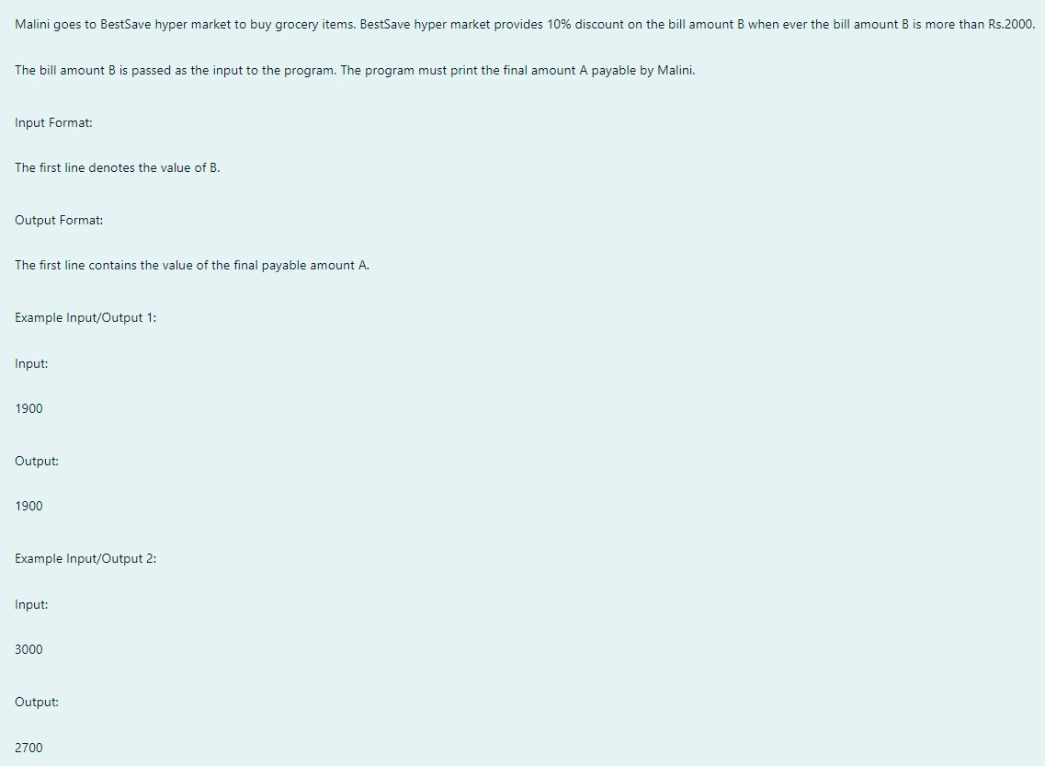

**ALGORITHM:**

Step 1: Start

Step 2: Input the bill amount b

Step 3: If b > 2000, calculate a discount of 10% and subtract it from b to get the final amount f Step 4: If b <= 2000, set f = b

Step 5: Print f

Step 6: Stop

**PROGRAM:**

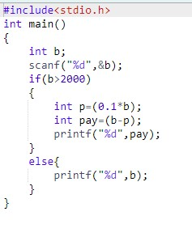

**OUTPUT:**

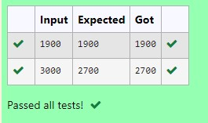

**RESULT:**

The above program is executed successfully.

**QUESTION 1.D**

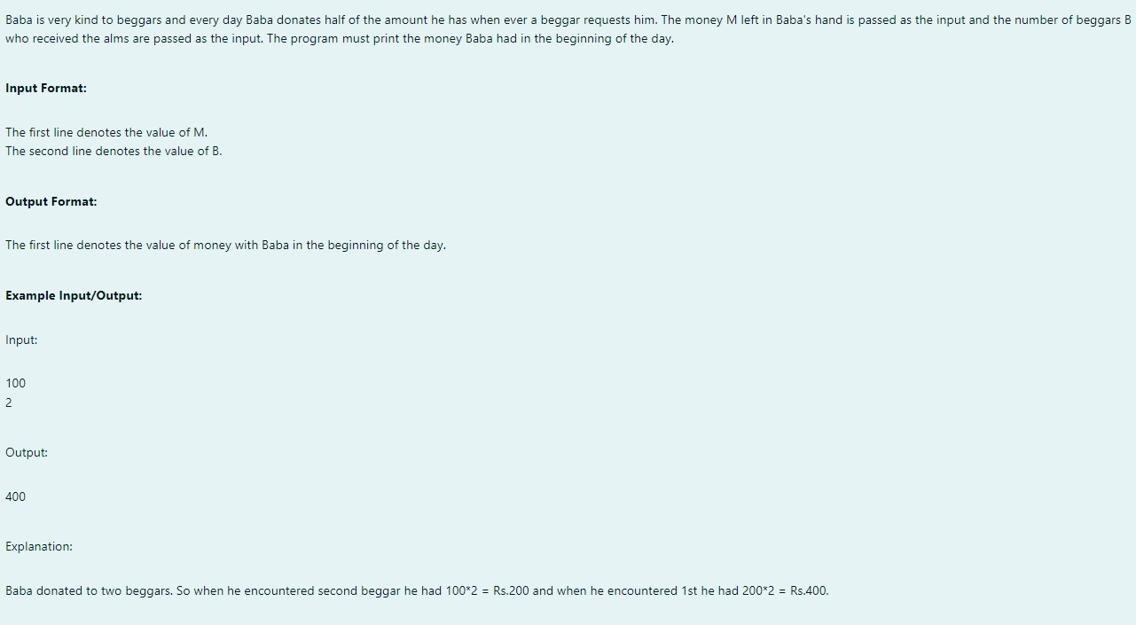

**ALGORITHM:**

Step 1: Start

Step 2: Input integers m and b

Step 3: While b is not zero, double the value of m and decrement b by 1 Step 4: Print the value of m

Step 5: Stop

**PROGRAM:**

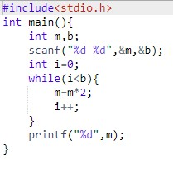

**OUTPUT:**

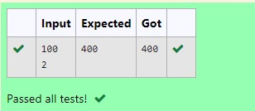

**RESULT:**

The above program is executed successfully.

**QUESTION 1.E** **AIM:**

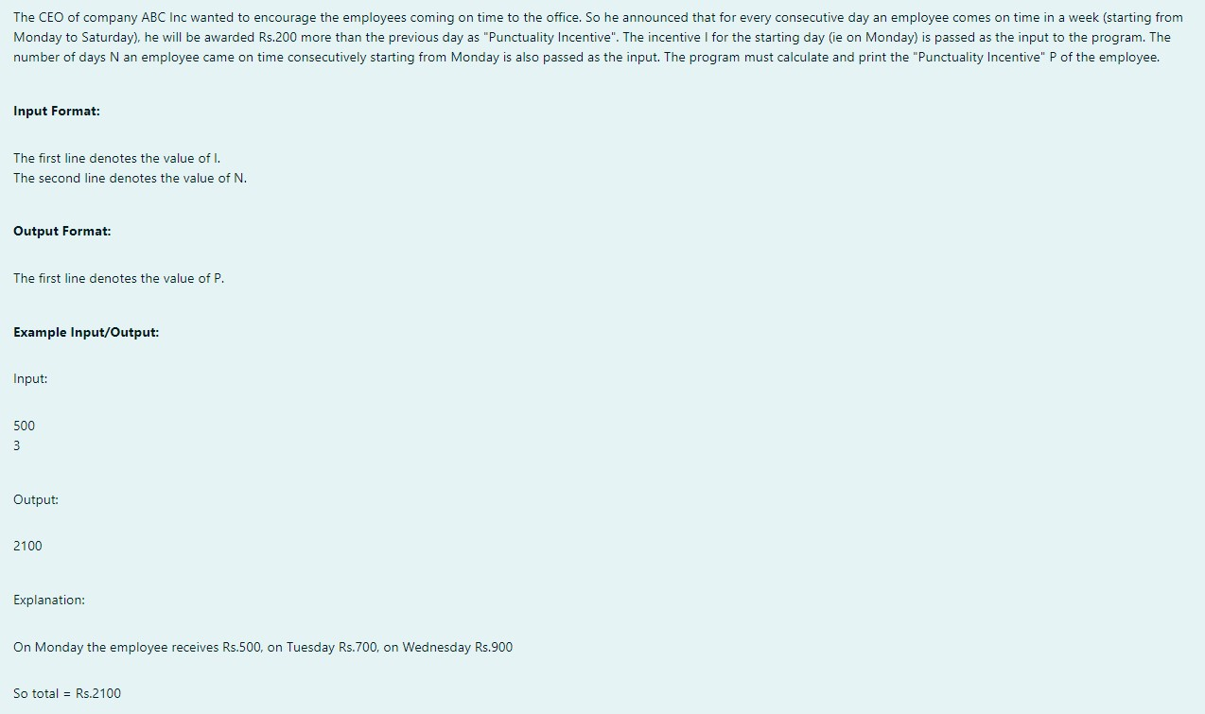

**ALGORITHM:**

Step 1: Start

Step 2: Input integers i and d Step 3: Initialize s with the value of i

Step 4: While d > 1, add 200 to i, add i to s, and decrement d by 1

Step 5: Print the value of s

Step 6: Stop

**PROGRAM:**

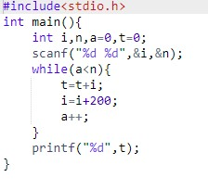

**OUTPUT:**

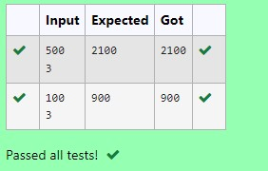

**RESULT:**

The above program is executed successfully.

**QUESTION 1.F**

**AIM:**

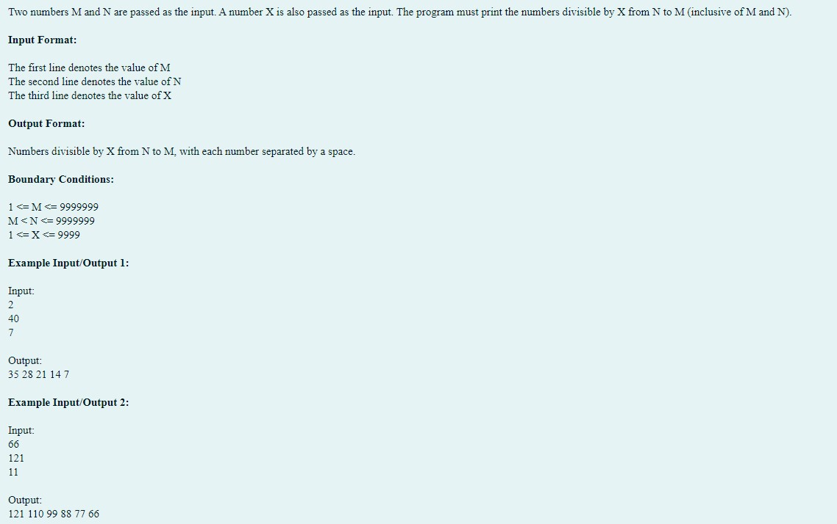

**ALGORITHM:**

Step 1: Start

Step 2: Input integers m, n, and x Step 3: Initialize i with the value of n

Step 4: While i >= m, if i is divisible by x, print i

Step 5: Decrement i by 1

Step 6: Stop

**PROGRAM:**

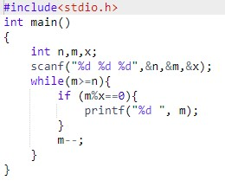

**OUTPUT:**

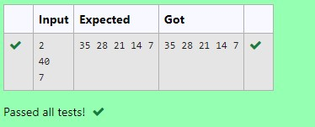

**RESULT:**

The above program is executed successfully.

**QUESTION 1.G AIM:**

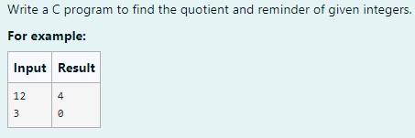

**ALGORITHM:**

Step 1: Start

Step 2: Input integers a and d

Step 3: Calculate the quotient q = a / d and remainder r = a % d

Step 4: Print q and r

Step 5: Stop

**PROGRAM:**

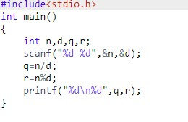

**OUTPUT:**

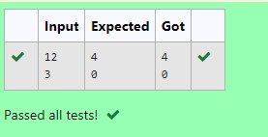

**RESULT:**

The above program is executed successfully.

**QUESTION 1.H**

**ALGORITHM:**

Step 1: Start

Step 2: Input three integers a, b, and c

Step 3: Check which of the three integers is the largest

Step 4: Print the largest integer

Step 5: Stop

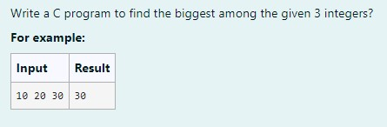  
**PROGRAM:**

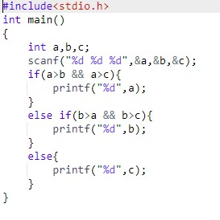

**OUTPUT:**

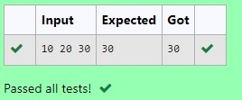

**RESULT:**

The above program is executed successfully.

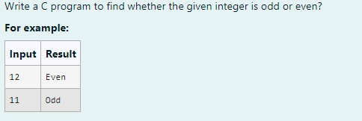

**ALGORITHM:**

Step 1: Start

Step 2: Input an integer a

Step 3: Check if a is even or odd

Step 4: Print "Even" if a is even; otherwise, print "Odd"

Step 5: Stop

**PROGRAM:**

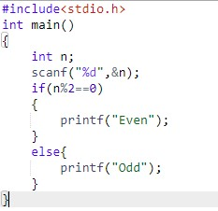

**OUTPUT:**

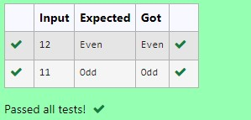

**RESULT:**

The above program is executed successfully.

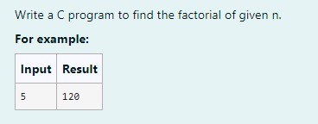

**ALGORITHM:**

Step 1: Start

Step 2: Input an integer a

Step 3: Set x = a

Step 4: While x > 1, decrement x by 1 and multiply it with a

Step 5: Print the final value of a

Step 6: Stop

**PROGRAM:**

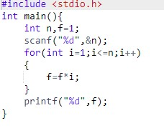

**OUTPUT:**

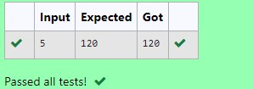

**RESULT:**

The **above** program is executed successfully.

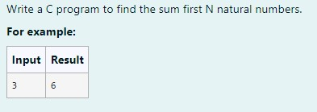

**ALGORITHM:**

Step 1: Start

Step 2: Input an integer a

Step 3: Initialize b = 0

Step 4: While a != 0, add a to b and decrement a by 1

Step 5: Print the value of b

Step 6: Stop

**PROGRAM:**

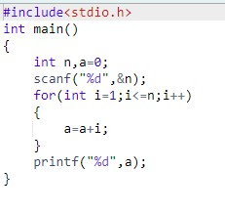**:**

**OUTPUT:**

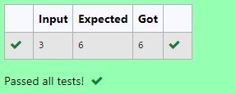

**RESULT:**

The above program is executed successfully.

**QUESTION 1.L**

**AIM:**

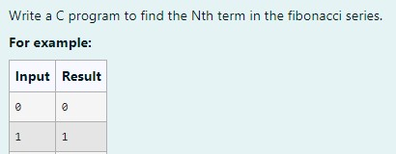

**ALGORITHM:**

Step 1: Start

Step 2: Input an integer n

Step 3: Define a recursive function fib(n) that returns fib(n-1) + fib(n-2) for n > 1 and n for n <= 1

Step 4: Print the result of fib(n)

Step 5: Stop

**PROGRAM:**

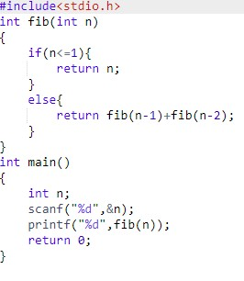

**OUTPUT:**

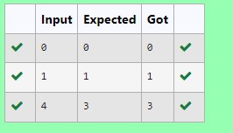

**RESULT:**

The above program is executed successfully.

**QUESTION 1.M**

**AIM:**

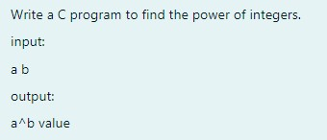

**ALGORITHM:**

Step 1: Start

Step 2: Input integers a and b

Step 3: Initialize i = 0 and p = 1

Step 4: While i < b, multiply p with a and increment i by 1

Step 5: Print the value of p

Step 6: Stop

**PROGRAM:**

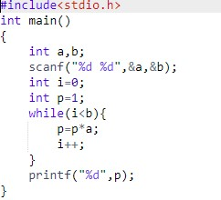

**OUTPUT:**

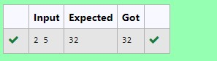

**RESULT:**

The above program is executed successfully.

**QUESTION 1.N**

**AIM:**

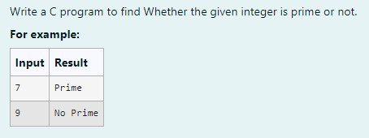

**ALGORITHM:**

Step 1: Start

Step 2: Input an integer n

Step 3: For each number i from 2 to n-1, check if n % i == 0 Step 4: If divisible, set flag = 1 and break; else, set flag = 0

Step 5: If flag == 0, print "Prime"; else, print "No Prime"

Step 6: Stop

**PROGRAM:**

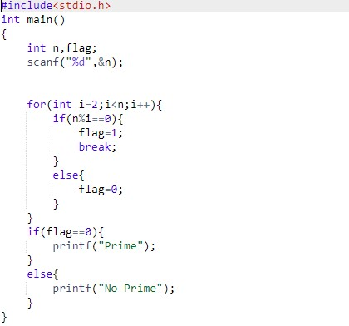

**OUTPUT:**

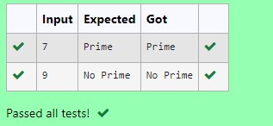

**RESULT**:

The above program is executed successfully.

**QUESTION 1.O**

**AIM:**



**ALGORITHM:**

Step 1: Start

Step 2: Input an integer n

Step 3: Initialize rev = 0

Step 4: While n != 0, calculate the remainder rem = n % 10

Step 5: Update rev = rev * 10 + rem and divide n by 10

Step 6: Print rev

Step 7: Stop

**PROGRAM:**

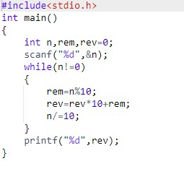

**OUTPUT:**

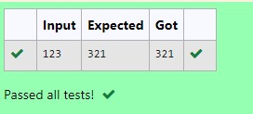

**RESULT:**

The above program is executed successfully.